# EECS 442 Homework 4

## Part 1. Pairwise images stitching:

### a. Brief description of algorithms:

Feature extraction: harris.m is used for feature extraction.

Feature distance computation: when the features are extracted with harris.m, find_feats.m is used to compute the SIFT feature descriptor of every feature. Then, The Euclidean distance of SIFT features is taken as the feature distance.

Putative matching: Since the dist2() function returns an matrix of feature distance, we just need to use the result and select the entries smaller than the threshold, which stand for the putative matches, and the indexes of these entries provides the putative matches of two images.

RANSAC: the algorithm of RANSAC is quite silimar to what the lecture slides said. The only difference is that the transform matrix is derived from all the inliers rather than the 4 groups of initial seed putative matches.

### b. Number of homography inliers: 132; avg_residual: 2.6397

### c. Images of pairwise images stitching:

With inlier matches shown:

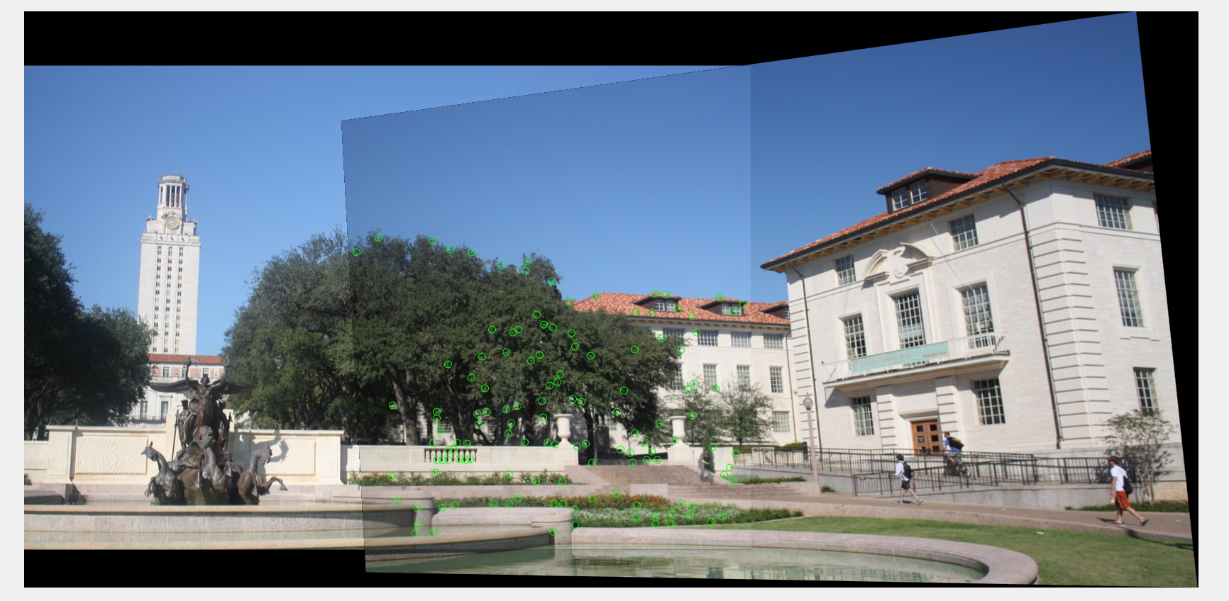

Without inlier matches shown:

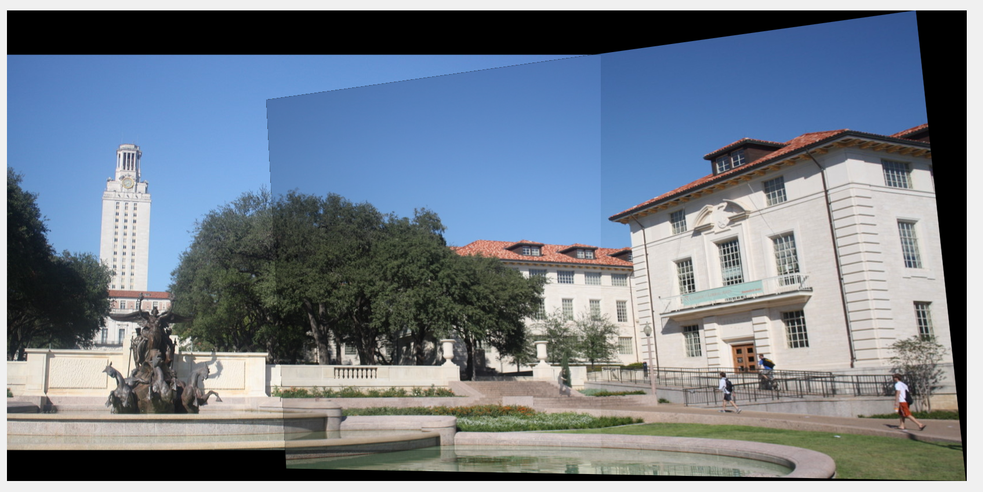

### Issues appeared:

1. The boundary of each image in the stitched image is clearly seen, that is because, the index of the boundary is not an integer, which will cause the dark boundary appeared in the stitched image.

2. Sometimes the stitching/overlapping part of the image is not clear enough (sometimes blur appeared and the stitching results are not always the same, especially in the multiple images stitching). The reason is that the find_sift() function just provide us with non-rotation-invariant SIFT descriptors, thus, the dominant gradient orientation is not aligned, which will sometimes prevent us from getting the best stitching result. And the randomness of RANSAC is also a more significant reason.

## Part 2. Multiple images stitching:

### a. Brief description of algorithms:

Since there are three pictures in each set to be stitched together (denote as img1, img2,img3), the number of inliers of img1&img2, img2&img3, img1&img3 are calculated, the combination of the three above, which has the fewest inliers, denotes that the two images of the combination will not be stitched together. For example, if img1&img3 has the fewest number of inliers, then img1 cannot be directedly stitched with img3. Thus, we will firstly stitch img1 and img2 and denote the stitched image as img12, then we will stitch img12 and img3.

Three different situations are considered and the corresponding merging order:

situation 1: 2,3 cannot be stitched together:

first stitch img3 and img1 as img31, then stitch img31 and img2 as the final stitched image.

situation 2: 1,3 are not be stitched together:

first stitch img1 and img2 as img12, then stitch img12 and img3 as the final stitched image.

situation 3: 1,2 are not be stitched together:

first stitch img1 and img3 as img13, then stitch img13 and img2 as the final stitched image.

### b. number of inliers(red denotes be chosen for merge):

|  |  |  |  |
| --- | --- | --- | --- |
|  | img1&img2 | img1&img3 | img2&img3 |
| hill | 110 | 47 | 139 |
| ledge | 191 | 110 | 188 |
| pier | 68 | 62 | 75 |

### c. Images of triple images stitching:

**Hill:**

With inlier matches shown:

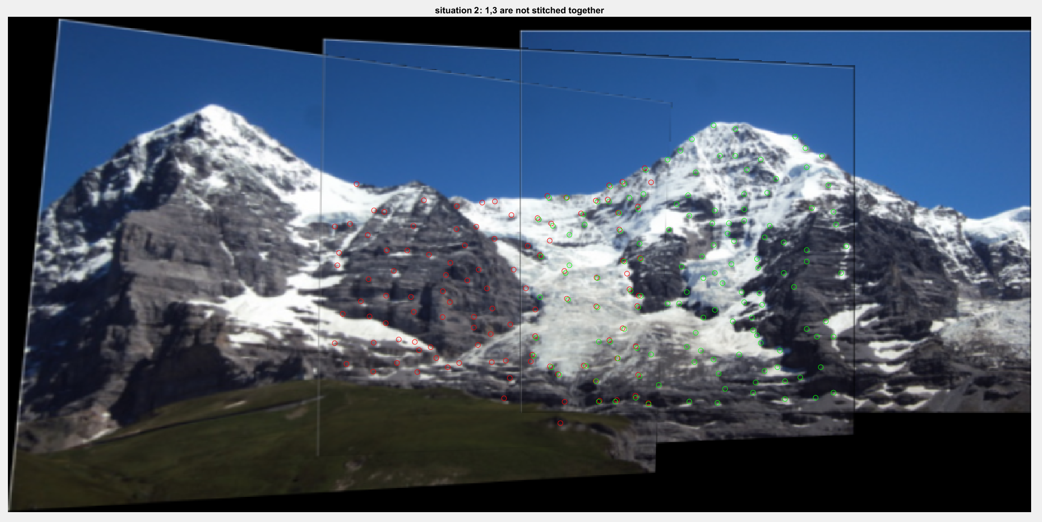

Without inlier matches shown:

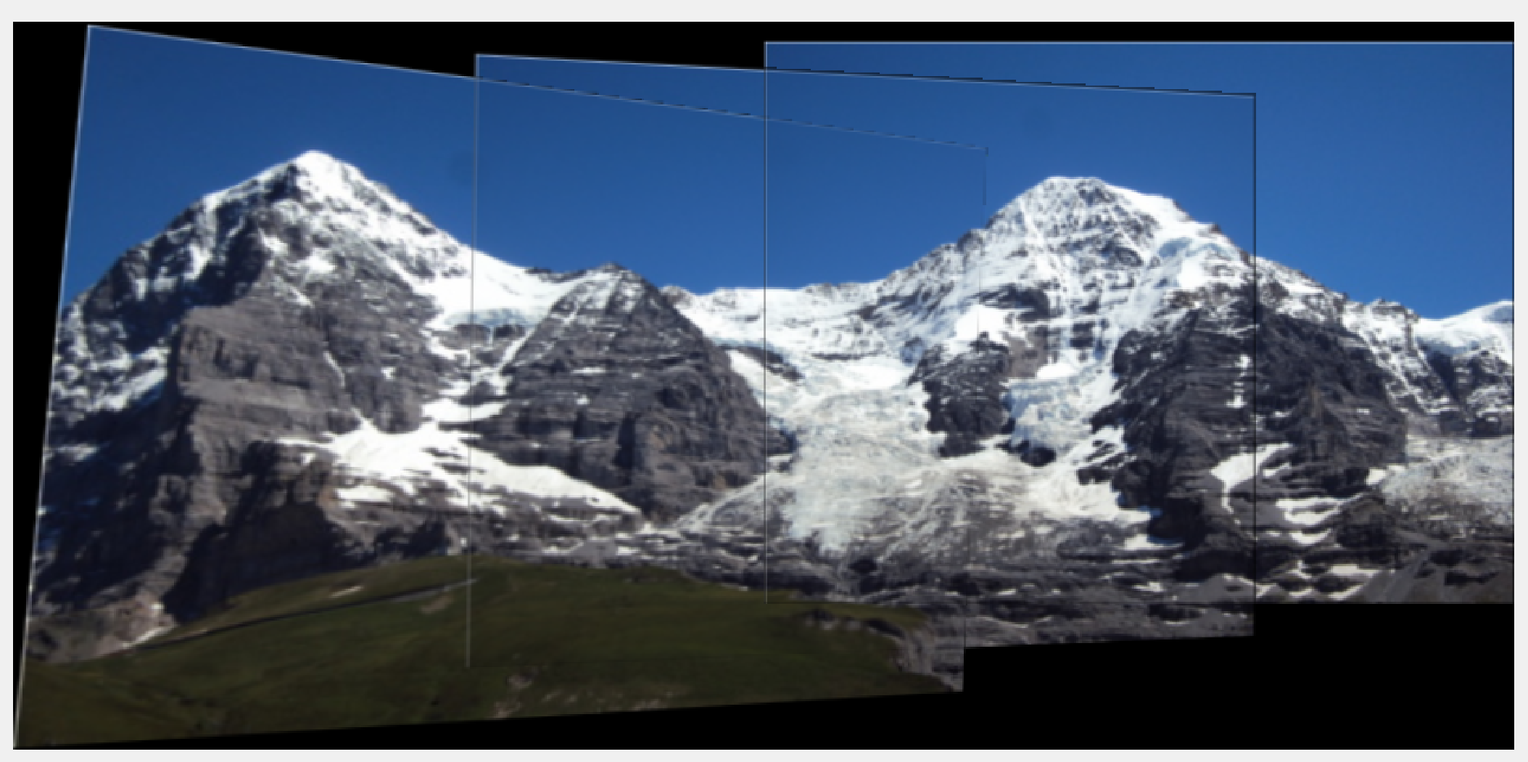

**Ledge**:

With inlier matches shown:

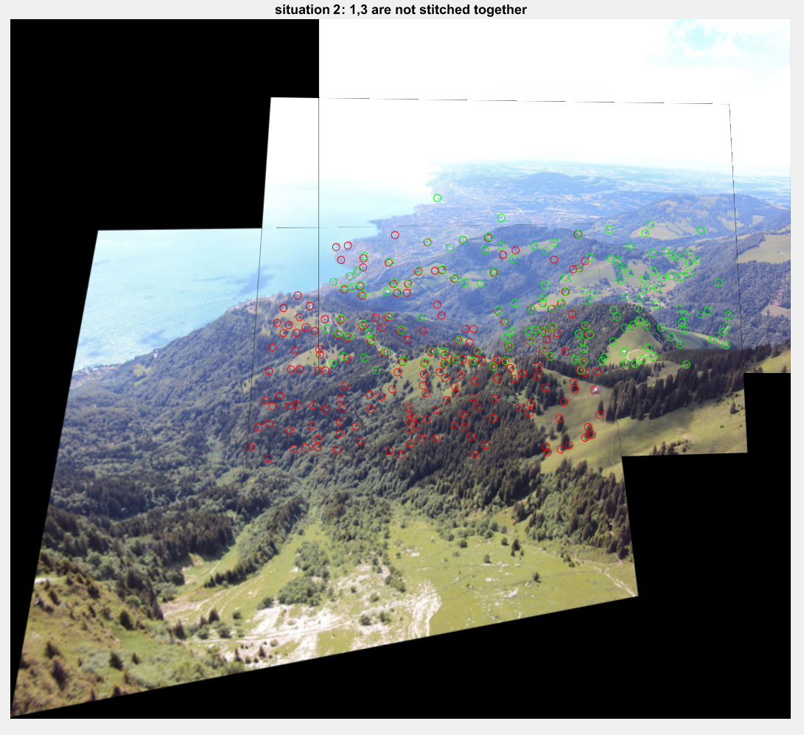

Without inlier matches shown:

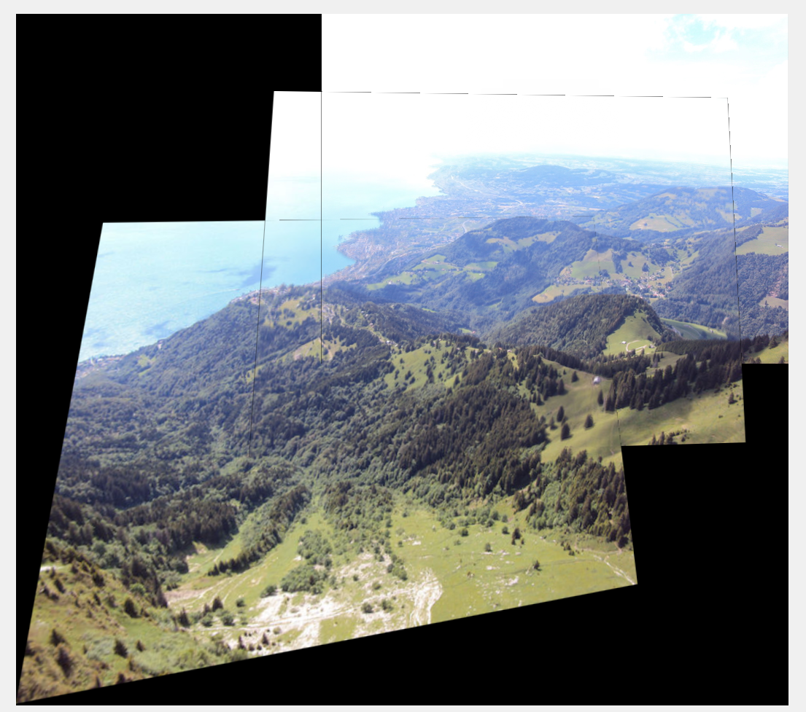

**Pier**:

With inlier matches shown:

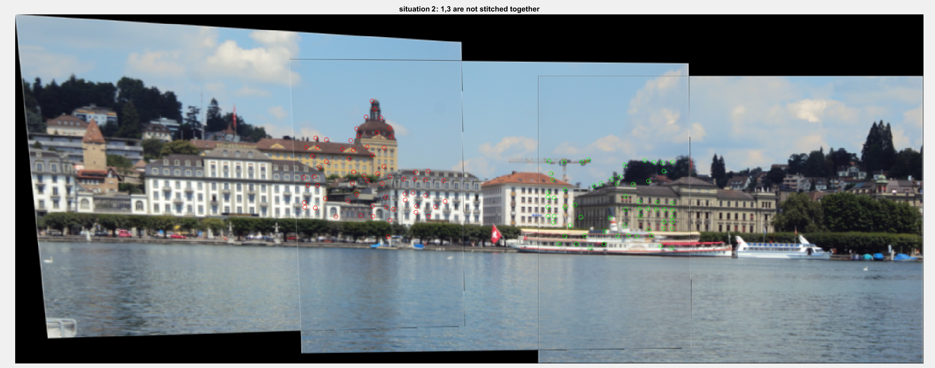

Without inlier matches shown:

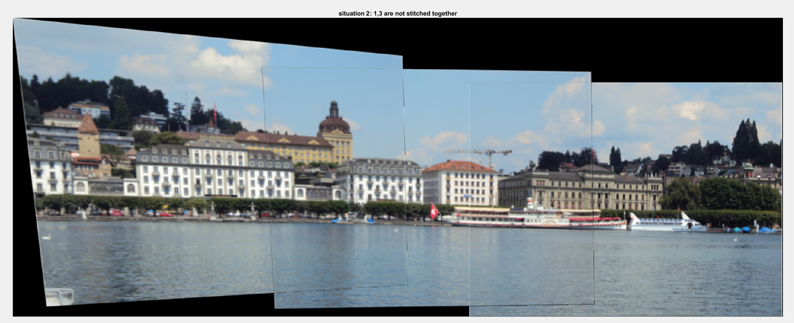

### Issues appeared:

1. The boundary of each image in the stitched image is clearly seen, that is because, the index of the boundary is not an integer, which will cause the dark boundary appeared in the stitched image.

2. Sometimes the stitching/overlapping part of the image is not clear enough (sometimes blur appeared like shown in the below pictures of pier, especially the windows of the building in the stitching part). The reason is that the find_sift() function just provide us with non-rotation-invariant SIFT descriptors, thus, the dominant gradient orientation is not aligned, which will sometimes prevent us from getting the best stitching result. And the randomness of RANSAC is also a more significant reason.

3. In pier set, the number of inliers of img1 and img3 are a bit high, but img1 and img3, obviously should be directedly stitched together. That is because the arrangement and the feature of the window of the building are similar, which cause many ‘inliers’.

